**Digital Transformation: Enhancing IoT**

**-**

**driven Solutions for Smart Islands**

___________________________

Mohammed Al

-

Ajmi,

Senior Lecturer.

University of Technology and Applied Science, HCT

Mohammed.alajmi@hct.edu.om



Applied Use Cases in the implementing Smart Islands

–

Use Cases



# Mohammed Khamis Al-Ajmi

Information Technology Authority

Head of Quality & Analyst in Digital Forensics - National Digital ForensicLab - Oman CERT

Analyst and Quality Executive in Digital Forensics - National DigitalForensic Lab - Oman

CERT



▪

▪



Head of Educational Technology, Middle East College Author of Books (Arabic):

Guide To Microsoft Servers

The 7 Element of Digital Citizenship

[LinkedIn](https://www.linkedin.com/in/malajmi30/)

**Upon completion of this course, the Participant will be able to:**

• Apply / Implement the previous learning in real world use cases ( 5 use cases).

# Use Cases

## 1. Enterprise Data Backup

**Use Case Description**

* ABC Enterprise currently keeps 18 months of CRM data in RDBMS and 7 years of archived data on tapes.
* ABC Enterprise wants to move from tape backups to HDFS backups
* Access of data is easier
* Can use commodity hardware with potential to move to the cloud
* No offline backups required
* Provide adhoc querying capability on the data

# Use Cases

## 1. Enterprise Data Backup

**Characteristics**

|  |  |  |
| --- | --- | --- |
| **Characteristics** | **Type** | **Notes** |
| Sources | RDBMS |  |
| Data Types | Numeric and relational |  |
| Mode | Historical |  |
| Data Acquisition | Pull |  |
| Availability | After 1 day | Data needs to be available in the data warehouse after 1 day since the original data is created |
| Store type | Write once, read many |  |
| Response Times | As good as possible | Given adhoc querying requirements, queries can run for a few seconds. |
| Modelbuilding | None |  |

Online Training Course on “Digital Transformation: Enhancing IoT driven Solutions for Smart Islands”, 18-31 July 2022

# Use Cases

## 1. Enterprise Data Backup

|  |  |  |
| --- | --- | --- |
| **Module** | **Technology option** | **Notes** |
| Acquire | Sqoop | Default choice for Database Extract |
| Transport | N/A |  |
| Persist | HDFS | Store in native HDFS format as Sequence Files |
| Transform | N/A |  |
| Reporting | Impala | Basic adhoc querying tool |
| Advanced  Analytic | N/A |  |

**Big Data Solution** 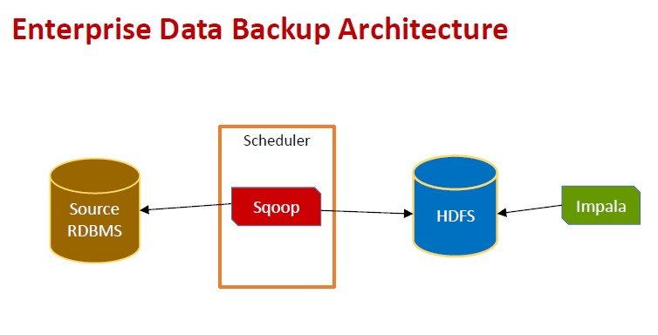

# Use Cases

**2. Media File Store Use Case Description**

* ABC Enterprise has contact center where all calls are recorded. These recordings need to be archived for analytics
* ABC Enterprise wants to move from tape archive to online archive
* Provide adhoc querying capability on the data

# Use Cases

## 2. Media File Store

**Characteristics**

|  |  |  |
| --- | --- | --- |
| **Characteristics** | **Type** | **Notes** |
| Sources | Contact Center recording solutions |  |
| Data Types | Media files |  |
| Mode | Historical |  |
| Data Acquisition | Pull |  |
| Availability | After 1 day | Data needs to be available in the media store after 1 day since the original data is created |
| Store type | Write once, read many |  |
| Response Times | As good as possible | Given adhoc querying requirements, queries can run for a few seconds. |
| Modelbuilding | None |  |

# Use Cases

## 2. Media File Store

|  |  |  |
| --- | --- | --- |
| **Module** | **Technology option** | **Notes** |
| Acquire | Files | Only choice for media files |
| Transport | FTP | Easy transfer; security and compression capable |
| Persist | HDFS, MYSQL | Media files stored in HDFS ; Meta-data and analytics stored in MySQL |
| Transform | Custom | Custom Media Analyzer for tagging media files and storing meta data |
| Reporting | Impala | Custom Media Reporting tool to analyze meta data and listen to recordings |
| Advanced  Analytic | N/A |  |

**Big Data Solution** 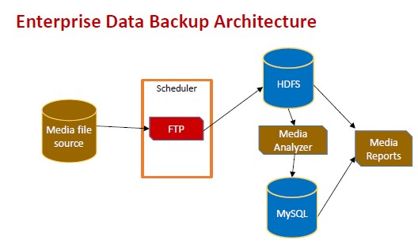

# Use Cases

## 3. Social Media Sentiment Analysis

**Use Case Description**

* ABC news corporation tracks popular topics on social media and uses them for their news reporting
* They want an automated system to capture social media interactions on popular topics and do real time sentiment analysis
* Sentiment Analysis need to be summarized and archived for future analysis too.

# Use Cases

## 3. Social Media Sentiment Analysis

**Characteristics**

|  |  |  |
| --- | --- | --- |
| **Characteristics** | **Type** | **Notes** |
| Sources | Twitter, Facebook | Social media popular topics. Topics are configurable |
| Data Types | Tweets, posts (JSON) |  |
| Mode | Real time |  |
| Data Acquisition | Streaming / push |  |
| Availability | Real time | On the fly analytics |
| Store type | Write many, read many |  |
| Response Times | Real time | Given adhoc querying requirements, queries can run for a few seconds. |
| Modelbuilding | Sentiment Analysis |  |

# Use Cases

## 3. Social Media Sentiment Analysis

**Big Data Solution**

|  |  |  |
| --- | --- | --- |
| **Module** | **Technology option** | **Notes** |
| Acquire | Streaming | Streaming supported by all social media websites |
| Transport | Kafka | Kafka provides scalable real time transport for data. Has interfaces to Twitter streaming as well as Spark |
| Persist | Cassandra | Store data by topic. The social media topic would be used as the key. |
| Transform | Apache Spark | Real time stream subscription and transformation |
| Reporting | Custom | Custom application for reading Cassandra data and summarizing for news |
| Advanced Analytic | Apache Spark | Sentiment Analysis on the fly with stream processing |

# Use Cases

## 3. Social Media Sentiment Analysis

**Big Data Solution**

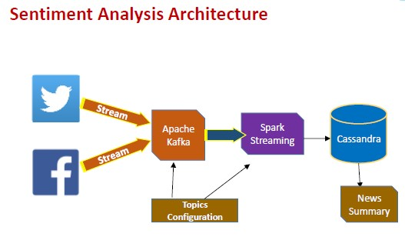

# Use Cases

## 4. Credit Card Fraud Detection

**Use Case Description**

* ABC Systems runs a web based retail solution where customers can order any kind of products (like Amazon)
* Sometimes credit card thieves use stolen information to make purchases. This later results in loss of revenue
* ABC systems needs a real time Credit Card Fraud prediction system so that the purchase is blocked before its complete.

# Use Cases

## 4. Credit Card Fraud Detection

**Characteristics**

|  |  |  |
| --- | --- | --- |
| **Characteristics** | **Type** | **Notes** |
| Sources | web transactions | Data is captured in real time while payment is being made on the web |
| Data Types | Numeric / CRM |  |
| Mode | Real time / Historical | Historical data collection ; prediction in real time |
| Data Acquisition | Streaming / push | Data pushed from browser as transactions happen |
| Availability | Real time | Real time predictions |
| Store type | Write once , read many |  |
| Response Times | Minimal | Prediction need to be made when the purchase is made. |
| Modelbuilding | Binary Classification | Model to predict if a transaction is fraudulent or not. |

# Use Cases

## 4. Credit Card Fraud Detection

**Big Data Solution**

|  |  |  |
| --- | --- | --- |
| **Module** | **Technology option** | **Notes** |
| Acquire | Web Events | Generated by custom web app. Deployed on a web farm |
| Transport | Kafka | Kafka provides scalable real time transport for data. Web Transaction events from web app. |
| Persist | MongoDB | Web events/transactions accumulated and stored in Mongo DB; Also models built are stored in Mongo DB |
| Transform | Spark |  |
| Reporting | None | Architecture can be enhanced to add adhoc reporting on the web transactions if required. |
| Advanced Analytic | Apache Spark | Binary Classification model building |

# Use Cases

## 4. Credit Card Fraud Detection

**Big Data Solution**

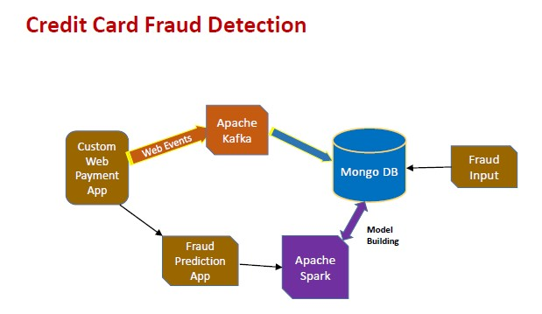

# Use Cases

## 5. Connected Car - IOT

**Use Case Description**

* ABC Car company wants to connect cars in real time to analytics engine
* Cars have multiple sensors. Sensor data need to be analyzed (real time / historical) to generate alarms for possible failures to the driver
* ABC needs a satellite enabled data collection and alarm system backed by a big data infrastructure

# Use Cases

## 5. Connected Car - IOT

**Characteristics**

|  |  |  |
| --- | --- | --- |
| **Characteristics** | **Type** | **Notes** |
| Sources | Car sensors | Sensors in car |
| Data Types | Numbers | Numeric event sensor data |
| Mode | Historical / Real time | Critical data processed real time. Rest historical |
| Data Acquisition | Push | Sensors send data to collection centers |
| Availability | Real time | Real time alarms needed |
| Store type | Write many, read many | Car profile need to be stored |
| Response Times | Real time | Real time profile fetches for real time alarming |
| Modelbuilding | Car issue prediction | Predict possible future issues |

# Use Cases

## 5. Connected Car - IOT

**Big Data Solution**

|  |  |  |
| --- | --- | --- |
| **Module** | **Technology option** | **Notes** |
| Acquire | Events from Car Sensors |  |
| Transport | ? |  |
| Persist | ? |  |
| Transform | ? |  |
| Reporting | Custom |  |
| Advanced Analytic | ? |  |

Replace the Question Mark (?) with appropriate Technology option for each Big Data Module.

# Use Cases

## 5. Connected Car - IOT

**Big Data Solution**

